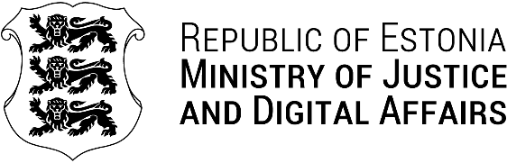

Your Ref: 12.02.2025 | No 10.1-13/892-1
Our Ref: 09.06.2025 | No 2-7/25-1566-2
HON. Mário Augosto Da Silva Oliveira
Office of The Minister of Telecommunications, Information Technologies and Social Communications

Decline of Participation

Your Excellency Minister Mário Augosto Da Silva Oliveira,

Thank you very much for the kind invitation to attend the upcoming ANGOTIC - Angola ICT Forum 2025. I truly appreciate the opportunity and the consideration!

Unfortunately, due to prior professional commitments during that period, I unfortunately will not be able to attend the ICT Forum this time. Nevertheless, I look forward to continued collaboration and future opportunities for engagement between our countries. Estonia and Angola share a joined vision and passion for digitalisation of our societies.

I would also like to take this opportunity to extend my heartfelt congratulations to the Republic of Angola on the 50th anniversary of Independence. We commend and recognise Angola’s commitment to advancing modern information and communication technologies as a key pillar of national development.

I wish you the best of success for the ANGOTIC - Angola ICT Forum 2025!

Yours sincerely,

H.E. Mrs. Liisa-Ly Pakosta
Minister of Justice and Digital Affairs of the Republic of Estonia

Tallinn, 9 June 2025

Kerstin Vaikmaa +372 58174356
Kerstin.Vaikmaa@justdigi.ee

